**Lab 2 report**

**Mobile Cloud Computing**

**By Rayan Katib**

**09-04-2013**

This lab assignment is based on tutorials 2 and 3. The first task is about creating a mobile web client application. Javascript, HTML5, CSS3, JQuery Mobile are the required platforms that should be used for this task. I implemented a simple application using jsFiddle. Here is a screenshot of the application using jsFiddle.

**http://jsfiddle.net/MU5xS/2/**

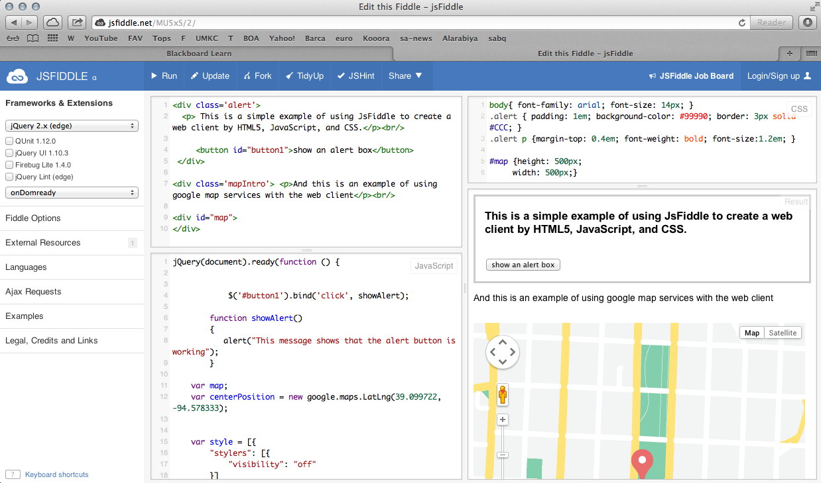

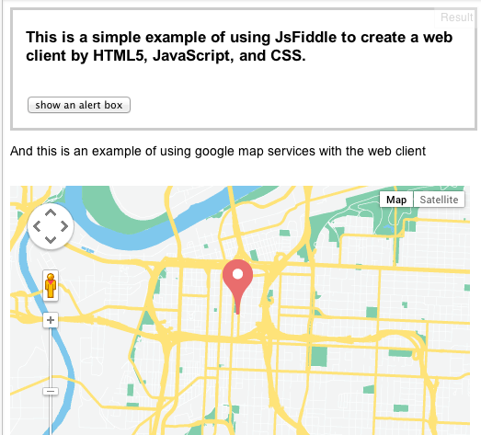

The second task is to use some web services for the application. I used Google Map Services to implement such a service in the application.

